LAB-05

1. AWS (Amazon Web Services)

Module 1: Global Infrastructure

Module 2: Structures of Cloud

Module 3: AWS Console

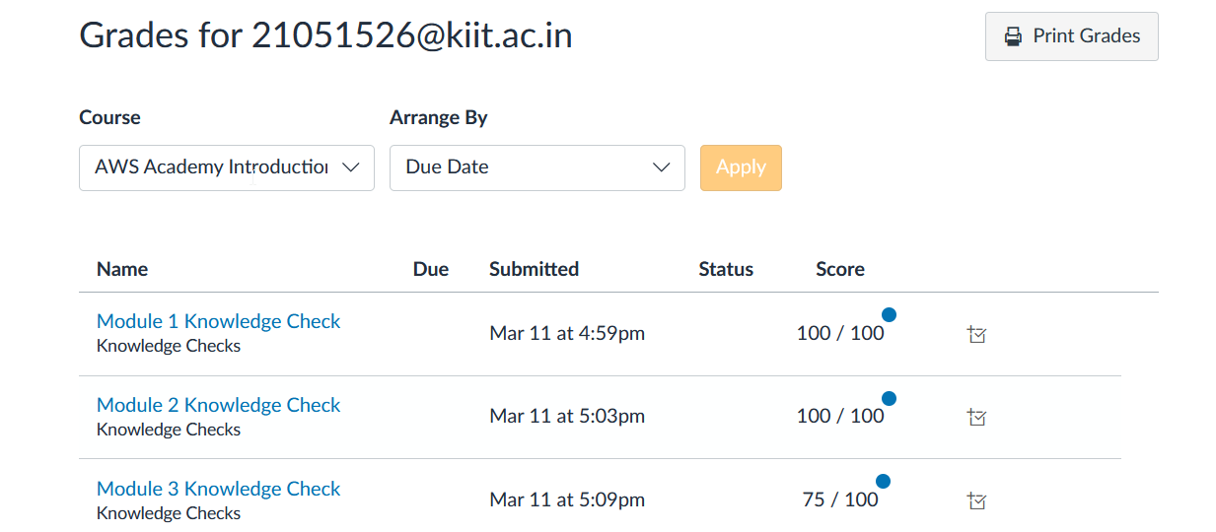

Module 4: Virtual Servers

Module 4.1: EC2

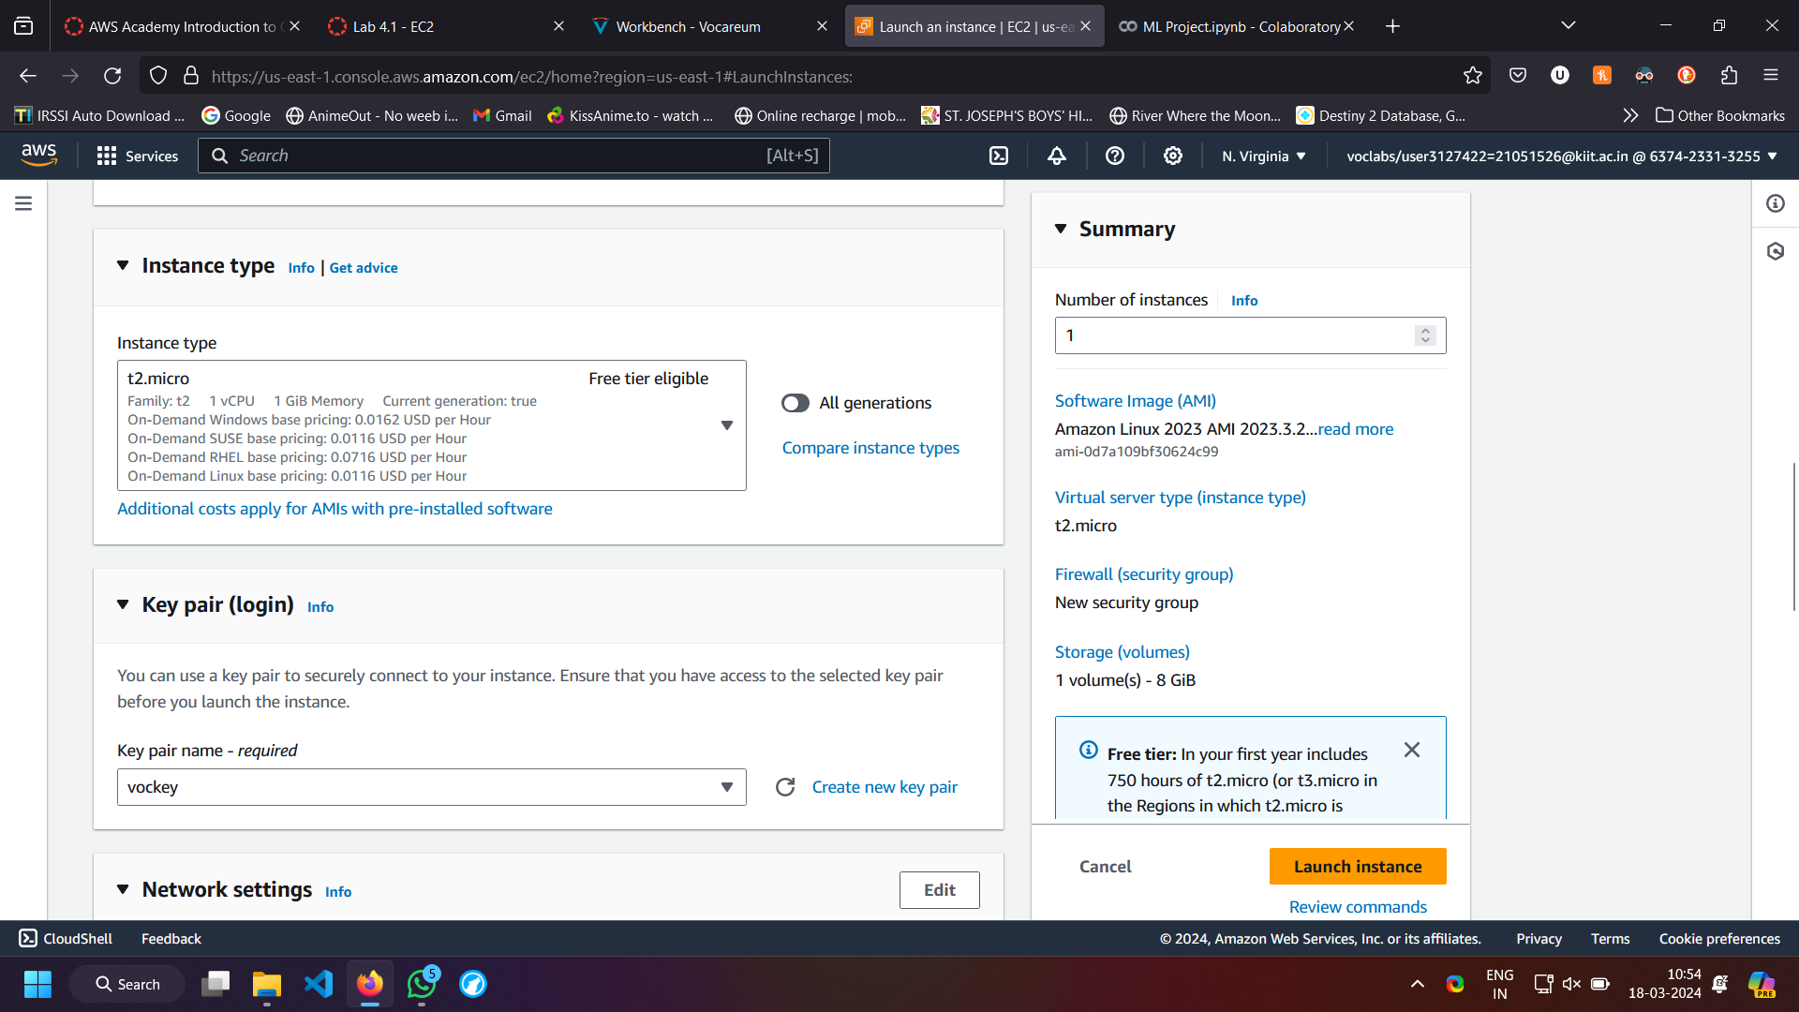

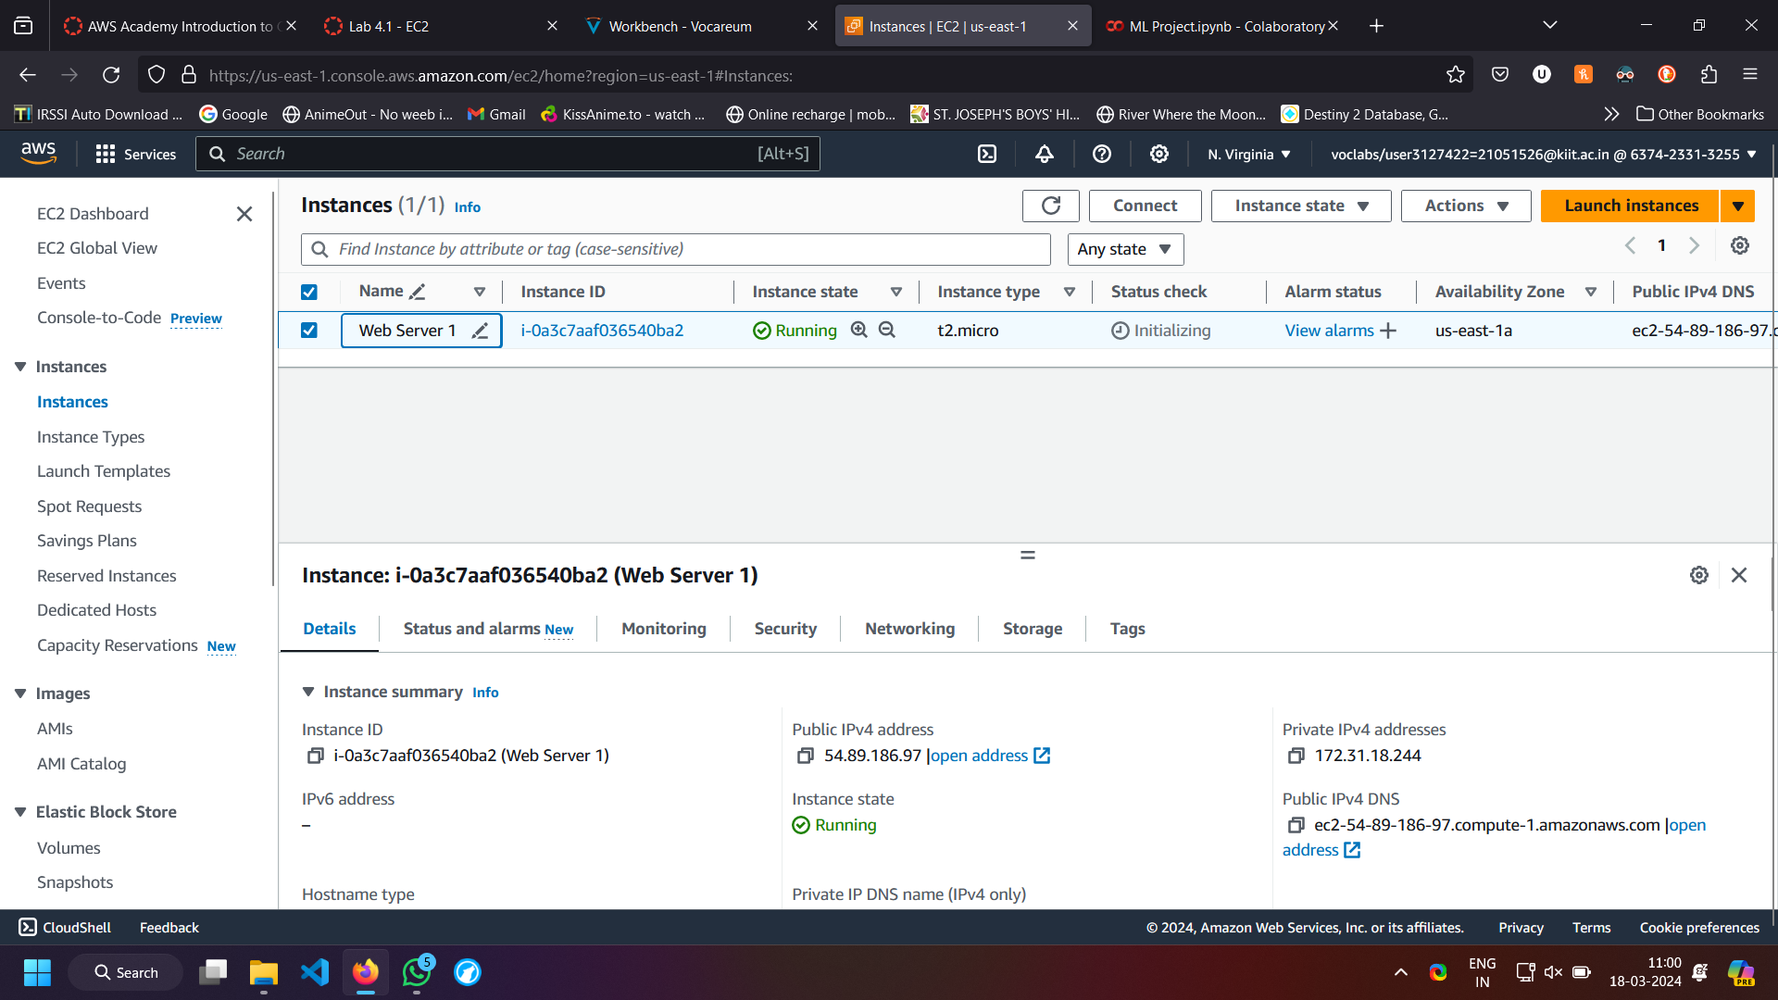

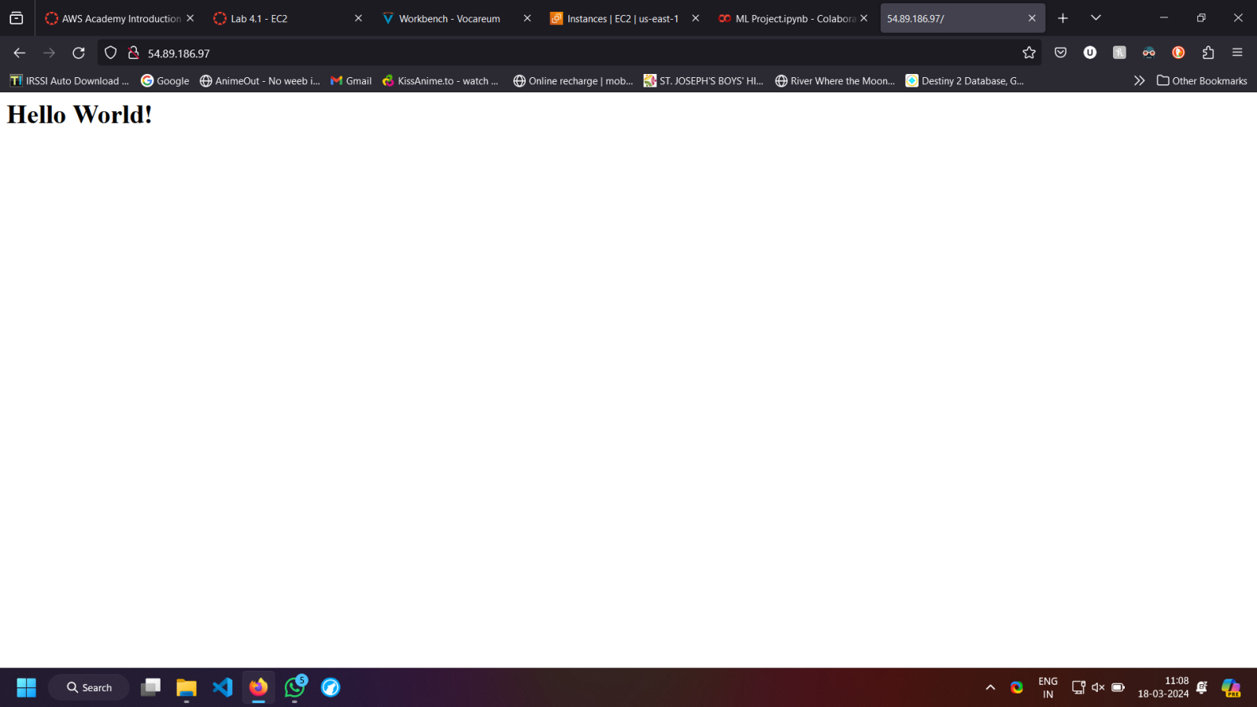

Module 4.2: S3

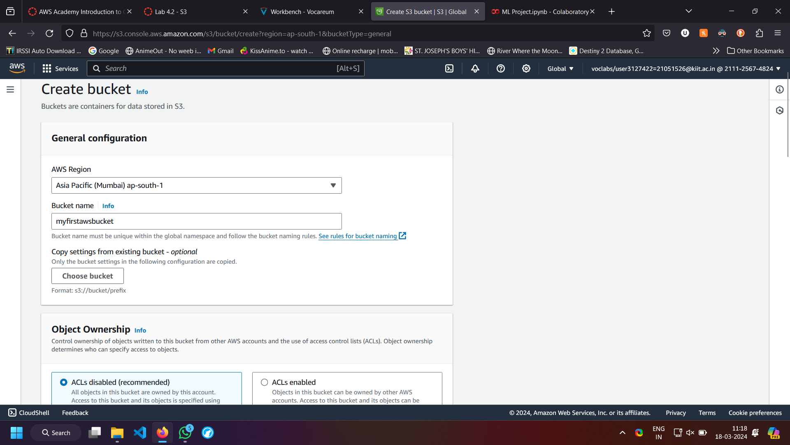

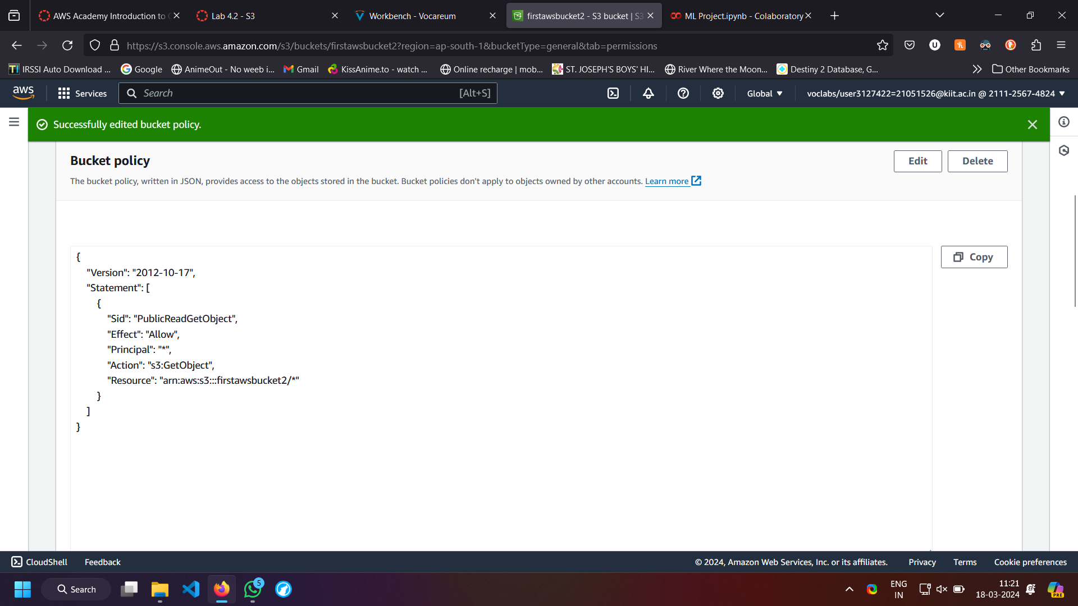

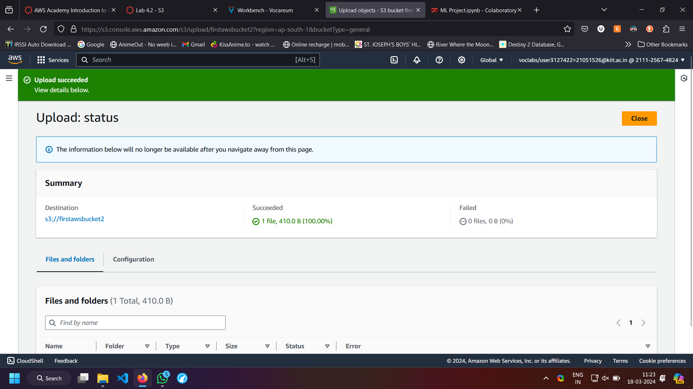

Name - Utkrist Jaiswal

Roll.no - 21051526